🐳
DOCKER
Comprehensive Guide
From First Concepts to Production — With Diagrams
Version  Docker 27.x+ | Audience  All Levels

Table of Contents

PART I — FOUNDATIONS

1. What Is Docker?
Docker is an open-source platform that helps developers build, share, and run applications inside lightweight, portable units called containers. Each container packages the application together with everything it needs — code, runtime, libraries, and configuration — so it runs identically on any machine.

The analogy: Think of Docker images like recipes and containers like the cooked dish. The same recipe (image) produces an identical dish (container) whether you cook it in your kitchen, a restaurant, or anywhere in the world.

1.1 The Problem Docker Solves
Pain Point | Without Docker | With Docker
Environment drift | "Works on my machine" — code behaves differently across dev, staging, prod | Identical container image runs in every environment, every time
Dependency conflicts | Multiple apps on the same server clash over library versions | Each app runs in total isolation with its own dependencies
Slow onboarding | New developers spend days setting up local environments | docker compose up — full environment in minutes
Scaling difficulty | Scaling means provisioning and configuring new VMs manually | Spin up identical container instances horizontally in seconds
Cloud lock-in | Apps tied to a specific OS or cloud provider | Same image deploys to AWS, GCP, Azure, or bare metal

1.2 Containers vs. Virtual Machines
Containers and VMs both provide isolation, but they work at completely different levels. Understanding this difference is fundamental to understanding why Docker is so fast and efficient.

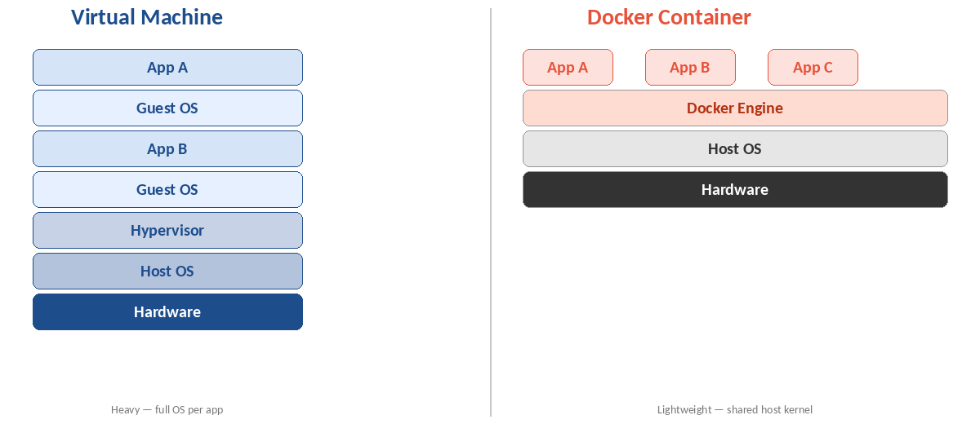
Figure: Containers share the host OS kernel; VMs each run a full guest OS
Attribute | Docker Container | Virtual Machine
OS overhead | Shares host kernel — no guest OS | Full guest OS per VM (GBs of overhead)
Startup time | Milliseconds | Minutes
Image size | Megabytes | Gigabytes
Isolation | Process-level (namespace + cgroups) | Hardware-level (hypervisor)
Performance | Near-native — minimal overhead | 10–20% overhead from hypervisor
Portability | Run anywhere Docker is installed | Hypervisor-specific format
Use together? | Yes — containers run inside cloud VMs | Yes — VMs are the host for Docker

💡 TIP
VMs and containers are not rivals — they're complementary. In production, Docker containers almost always run inside cloud VMs (AWS EC2, GCP Compute Engine, Azure VM). VMs provide the hardware isolation; Docker provides the application isolation.

2. Core Concepts
Five objects form the backbone of everything in Docker. Once you understand each one and how they relate, the rest of Docker clicks into place.

2.1 The Five Core Objects
Object | What It Is | Analogy
Dockerfile | Text file of build instructions | A recipe — step-by-step instructions to assemble the final dish
Image | Read-only snapshot built from a Dockerfile | The recipe executed — a sealed, reusable, shareable package
Container | A live, running instance of an image | The cooked dish — active, consuming resources, temporary
Volume | Persistent storage outside the container lifecycle | A fridge — data that outlives any individual meal
Network | Virtual network connecting containers | The dining table — where containers talk to each other

2.2 From Dockerfile to Running Container
Every Docker workflow follows this exact path. Understanding the flow makes commands and errors instantly readable.

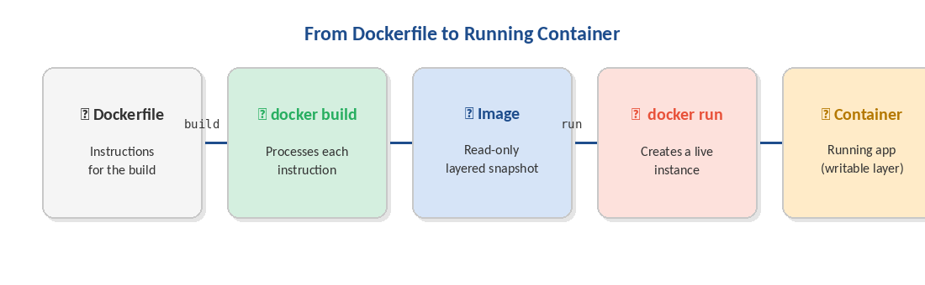
Figure: Dockerfile → build → Image → run → Container
- Write a Dockerfile describing your application environment
- Run docker build to process each instruction and produce a layered image
- Optionally push the image to a registry so teammates and CI/CD can pull it
- Run docker run to create a live container instance from the image
- The image is unchanged — each docker run creates a fresh, independent container

PART II — HOW DOCKER WORKS

3. Docker Engine
Docker Engine is the core runtime that makes everything work. It is a client-server system with three tightly integrated components that communicate to build, manage, and run containers.

3.1 Docker Desktop — What's Inside the Box
Docker Desktop is the GUI application most developers install on macOS and Windows. Under the hood it bundles the full Docker Engine plus a visual interface. Understanding its internals demystifies how Docker actually works on your laptop.

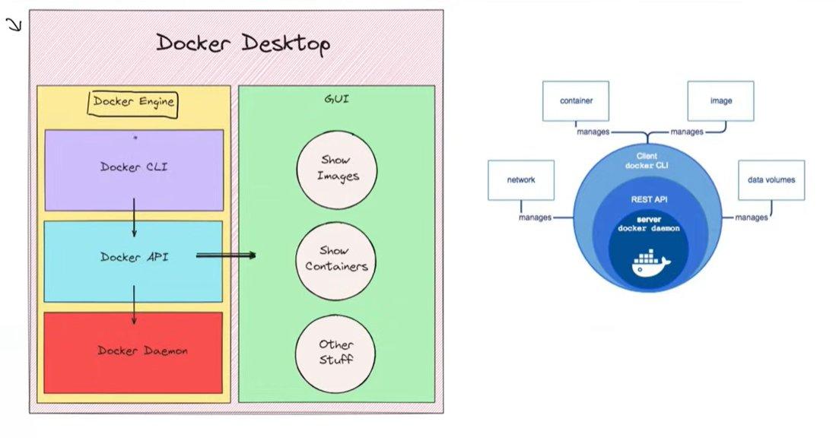
Figure: Docker Desktop: Docker Engine (CLI → API → Daemon) alongside a GUI. The circular diagram shows how CLI, REST API, and Daemon nest together to manage all Docker objects.
The left panel shows the Docker Engine — the three components doing all the real work. The right GUI panel is simply a wrapper that calls the same Docker API your terminal does. The circular diagram on the right illustrates the nesting: Docker CLI (client) wraps the REST API, which wraps the server daemon — together managing containers, images, networks, and volumes.

3.2 The Three Components in Detail
- Docker Daemon (dockerd) — The server. A background process that manages all Docker objects: images, containers, networks, and volumes. It listens for API requests and handles all container lifecycle operations (start, stop, restart, delete).
- Docker CLI (docker) — The client. The command-line tool you interact with directly. It translates commands like docker run and docker build into REST API calls sent to the daemon.
- REST API — The bridge. The communication layer between the CLI and the daemon. Publicly documented and available, it also enables programmatic integration — CI/CD tools, dashboards, and orchestrators all speak this API.

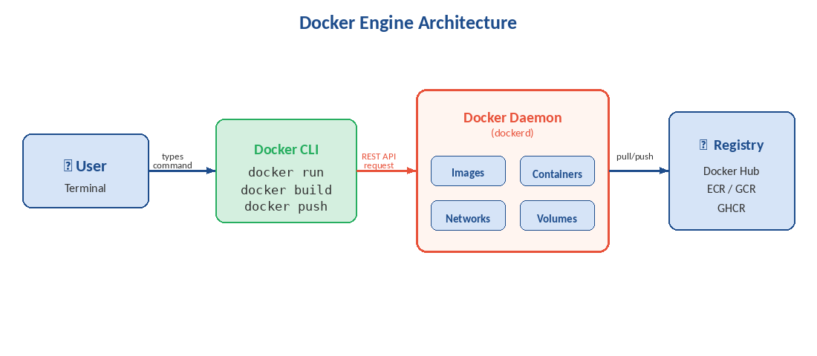
Figure: End-to-end flow: User → CLI → REST API → Daemon → Registry

💡 TIP
The CLI and daemon don't have to be on the same machine. Docker Desktop uses this split — the CLI runs natively on your laptop and communicates with a daemon inside a lightweight Linux VM. This is also how remote Docker contexts work.

3.3 What Happens When You Run docker run nginx
- You type docker run nginx in your terminal
- The Docker CLI converts this into a POST /containers/create REST API request
- The daemon (dockerd) receives the request
- The daemon checks local image storage — no nginx image found
- The daemon contacts Docker Hub and pulls the nginx image layer by layer
- The daemon instructs containerd (the low-level runtime) to create the container
- The container starts; the daemon reports the container ID back to the CLI

4. Docker Images
A Docker image is a read-only, layered snapshot of a filesystem and the configuration needed to run an application. It is the sharable, portable artifact that guarantees "if it works here, it works everywhere".

4.1 What a Docker Image Contains
- Base Image: The starting layer — a minimal OS (alpine, ubuntu) or language runtime (python:3.12, node:20)
- Application Code: Your source files, copied in at build time
- Dependencies: Every library, framework, and package the application requires
- Metadata: Environment variables, exposed ports, labels, and the default startup command

📘 NOTE
Images are immutable and layered. Each Dockerfile instruction adds a new read-only layer. Layers are cached and shared — if two images share a base, that base layer is stored only once on disk, making pulls and builds dramatically faster.

4.2 Image Lifecycle
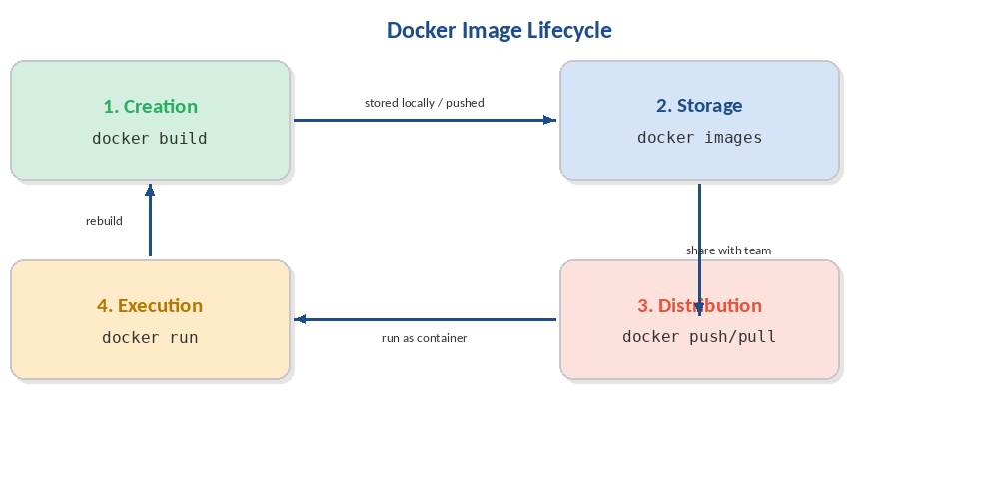
Figure: The four stages every Docker image passes through
Stage | Command | What Happens
Creation | docker build | Dockerfile processed instruction-by-instruction; each step creates an immutable cached layer
Storage | docker images | Image lives on local disk or in a registry (Docker Hub, ECR, GCR) for shared access
Distribution | docker push / pull | Share via registry; teammates and CI/CD pull the identical image — no environment differences
Execution | docker run | A live, writable container is created; the image stays unchanged; every run is a fresh instance

4.3 Image vs. Container — The Most Important Distinction
Dimension | Image | Container
State | Static, read-only snapshot | Live, running process with a writable layer on top
Analogy | A recipe / a class definition | The cooked dish / an object instance
Multiplicity | One image → many containers | Each container is independent; changes don't affect others
Lifespan | Permanent until explicitly deleted | Temporary — data is lost on removal unless volumes are used
Storage | Layered, shared, efficient | Thin writable layer on top of image layers

5. Writing Dockerfiles
A Dockerfile is the blueprint for building a Docker image. Every instruction creates a new immutable layer. Writing efficient Dockerfiles directly impacts build speed, image size, and security.

5.1 Instruction Reference
Command | Description
FROM image:tag | Set the base image — always the first instruction
RUN command | Execute a shell command during build (installs packages, compiles code)
COPY src dest | Copy files from build context into the image
ADD src dest | Like COPY but also supports URLs and auto-extracts tar archives
WORKDIR /path | Set the working directory for all following instructions
ENV KEY=VALUE | Set environment variables available at build AND runtime
ARG NAME=default | Build-time variable (not available in the running container)
EXPOSE port | Document which port the app listens on (informational only)
VOLUME ["/data"] | Create a mount point for persistent external data
USER name | Switch to a non-root user — critical for security
LABEL key=value | Add metadata: version, maintainer, description
HEALTHCHECK CMD ... | Define a command Docker uses to test if the container is healthy
CMD ["app"] | Default command when the container starts (overridable at runtime)
ENTRYPOINT ["app"] | Main executable — not easily overridden; use with CMD for args

5.2 Python Application — Annotated Example
This is the pattern from the source material — a production-ready Python Dockerfile:
# Use an official Python runtime as a base image
FROM python:3.8-slim

# Set the working directory inside the container
WORKDIR /app

# Copy dependency file first — leverages Docker layer caching
# If requirements.txt hasn't changed, Docker reuses the cached layer
COPY requirements.txt ./

# Install dependencies — separate layer so they're cached independently
RUN pip install --no-cache-dir -r requirements.txt

# Copy the rest of the application source code
COPY . /app

# Document the port this application listens on
EXPOSE 80

# Set an environment variable
ENV NAME World

# Run the application when the container launches
CMD ["python", "app.py"]

5.3 Layer Caching — The Golden Rule
Put things that change least at the top, things that change most at the bottom.

- Base image (FROM) — changes almost never
- System packages (RUN apt-get install) — changes rarely
- Dependency files (package.json, requirements.txt) — changes occasionally
- Source code (COPY . .) — changes constantly → put last

# ❌ BAD: source code copied before dependencies
# Every code change invalidates the npm install layer
COPY . .
RUN npm install

# ✅ GOOD: dependencies cached independently from source code
# npm install only re-runs when package.json changes
COPY package*.json ./
RUN npm install
COPY . .

5.4 Multi-Stage Builds
Multi-stage builds use multiple FROM statements to separate the build environment from the production runtime. The final image contains only what's needed to run — not the compiler, test tools, or source code.
# ── STAGE 1: Build ──────────────────────────────────────
FROM golang:1.22 AS builder
WORKDIR /app
COPY go.mod go.sum ./
RUN go mod download
COPY . .
RUN CGO_ENABLED=0 go build -o myapp .

# ── STAGE 2: Production (scratch = empty image) ─────────
FROM scratch
COPY --from=builder /app/myapp /myapp
ENTRYPOINT ["/myapp"]

# Result: ~5MB image vs ~800MB with the full Go toolchain

💡 TIP
Always use a .dockerignore file to exclude node_modules/, .git/, *.log, .env, and test artifacts from the build context. A leaner context means faster builds and smaller images.

PART III — RUNNING & MANAGING

6. Core Docker Commands

6.1 Image Commands
Command | Description
docker build -t name:tag . | Build image from Dockerfile in current directory
docker images | List all local images
docker pull image:tag | Download image from registry
docker push image:tag | Upload image to registry
docker rmi image | Remove a local image
docker image prune -a | Remove all unused images
docker inspect image | Show full metadata and layer info
docker history image | Show layers and the commands that created them

6.2 Container Commands
Command | Description
docker run image | Create and start a new container
docker run -d image | Run container in background (detached)
docker run -it image bash | Run container with interactive terminal
docker run -p 8080:80 image | Map host port 8080 → container port 80
docker run -v vol:/data image | Mount volume into container
docker run --name app image | Give the container a name
docker run --rm image | Auto-remove container when it exits
docker ps | List running containers
docker ps -a | List all containers (including stopped)
docker stop container | Gracefully stop (SIGTERM → SIGKILL after timeout)
docker start container | Start a stopped container
docker rm container | Remove a stopped container
docker rm -f container | Force-remove a running container
docker exec -it app bash | Open interactive shell inside running container
docker logs -f container | Stream live logs
docker stats | Live CPU/memory usage for all containers
docker inspect container | Full container metadata as JSON

7. Docker Networking
Docker networking controls how containers communicate with each other and with the outside world. Understanding networking unlocks multi-service architectures.

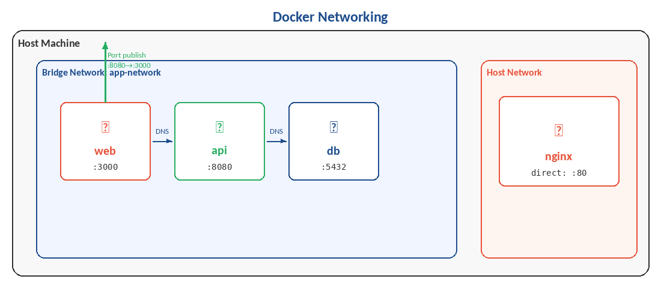
Figure: Containers on the same bridge network resolve each other by service name via DNS

7.1 Network Drivers
Command | Description
bridge (default) | Isolated private network on the host. Containers on the same bridge can communicate; containers on different bridges cannot.
host | Container shares the host's network stack directly. Maximum performance, zero isolation. Linux only.
none | Completely disables networking — for batch jobs that must not communicate.
overlay | Multi-host networking used by Docker Swarm and Kubernetes.
macvlan | Assigns a real MAC address to a container, making it appear as a physical device on your network.

7.2 Service Discovery via DNS
On a user-defined bridge network, containers reach each other by name — Docker handles DNS automatically. This is why a web service can simply reference 'db' as the database hostname:
# In docker-compose.yml — containers on the same network
# reach each other by service name, not IP address
DATABASE_URL=postgres://user:pass@db:5432/mydb
^^
'db' resolves to the database container's IP automatically

7.3 Port Publishing
# Expose port 80 of container on port 8080 of the host
docker run -p 8080:80 nginx

# Bind only to localhost (don't expose on the network)
docker run -p 127.0.0.1:8080:80 nginx

# Publish all EXPOSE'd ports to random host ports
docker run -P nginx

8. Data Persistence with Volumes
Containers are ephemeral — any data written inside a container disappears when the container is removed. Docker provides three persistence mechanisms to solve this.

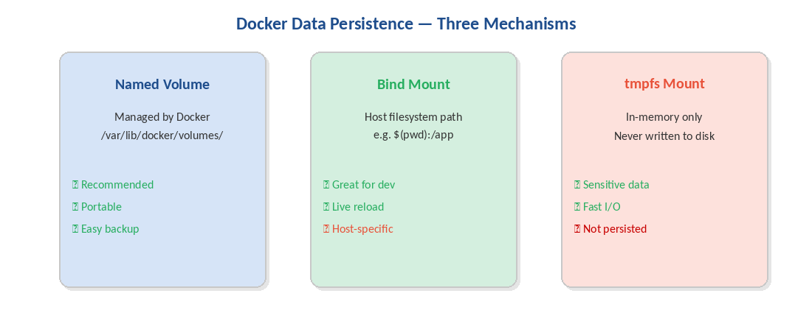
Figure: Three ways to persist data: named volumes, bind mounts, and tmpfs

8.1 Named Volumes (Recommended for Production)
Managed entirely by Docker. Stored under /var/lib/docker/volumes/ on the host. Portable, easy to back up, and the preferred choice for production data.
# Create a named volume
docker volume create mydata

# Mount it into a container
docker run -v mydata:/app/data myimage

# In docker-compose.yml
services:
db:
image: postgres:16
volumes:
- db-data:/var/lib/postgresql/data
volumes:
db-data:

8.2 Bind Mounts (Best for Development)
Links a specific path on the host filesystem directly into the container. Changes on the host are reflected instantly inside the container — ideal for live-reload development workflows.
# Mount current directory into /app (live code reload)
docker run -v $(pwd):/app myimage

# Read-only config bind mount
docker run -v $(pwd)/config:/app/config:ro myimage

💡 TIP
Use named volumes in production for reliability and portability. Use bind mounts in development for live code reloading. Never use bind mounts in production — they create a hard dependency on the host's directory structure.

9. Docker Compose
Docker Compose lets you define an entire multi-container application in a single YAML file and manage it with one command. It is the standard tool for local development and simple production deployments.

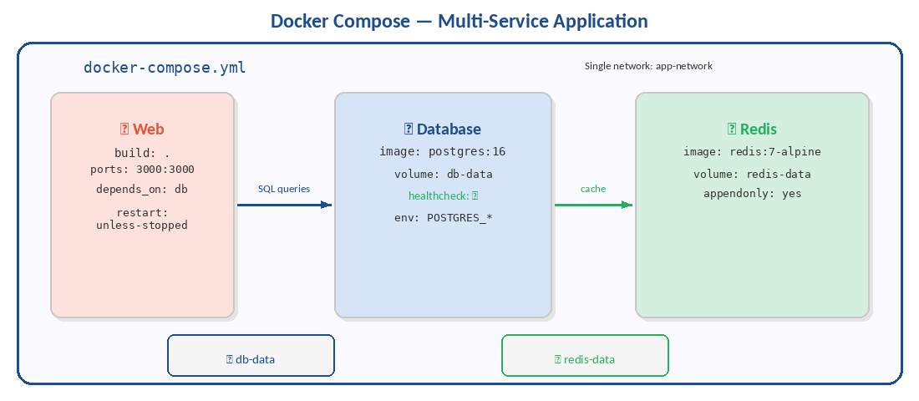
Figure: Docker Compose wires together web, database, and cache services on a shared network

9.1 A Complete docker-compose.yml
version: '3.9'

services:
web:
build: . # Build image from local Dockerfile
ports: ['3000:3000'] # Publish port
environment:
- NODE_ENV=production
- DATABASE_URL=postgres://user:pass@db:5432/mydb
depends_on:
db:
condition: service_healthy # Wait for DB health check to pass
restart: unless-stopped

db:
image: postgres:16-alpine
environment:
POSTGRES_USER: user
POSTGRES_PASSWORD: pass
POSTGRES_DB: mydb
volumes:
- db-data:/var/lib/postgresql/data
healthcheck:
test: ['CMD-SHELL', 'pg_isready -U user']
interval: 10s
timeout: 5s
retries: 5

redis:
image: redis:7-alpine
volumes: [redis-data:/data]

volumes:
db-data:
redis-data:

9.2 Essential Compose Commands
Command | Description
docker compose up -d | Create and start all services in background
docker compose up --build | Rebuild images before starting
docker compose down | Stop and remove containers and networks
docker compose down -v | Also remove volumes (destroys data!)
docker compose ps | Show status of all services
docker compose logs -f service | Follow logs for a specific service
docker compose exec svc sh | Open shell in a running service
docker compose restart service | Restart a specific service
docker compose build | Build or rebuild service images
docker compose config | Validate and view the resolved configuration

PART IV — REGISTRIES & DISTRIBUTION

10. Docker Registries
A Docker registry is the distribution backbone of the ecosystem. It stores images centrally and makes them available to any machine running Docker — exactly like GitHub for source code, but for container images.

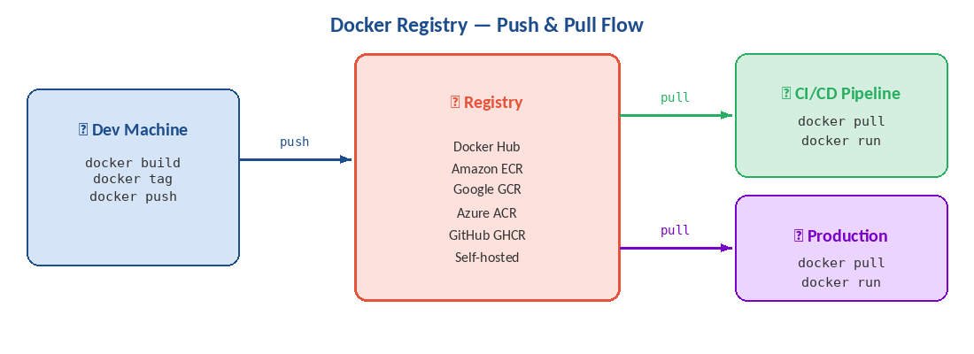
Figure: Push images from your dev machine; CI/CD and production pull from the same registry

10.1 Key Concepts
- Repository: A named collection of related images — all versions of one application. E.g., myapp. A registry holds many repositories.
- Tag: A version label within a repository. myapp:1.0, myapp:2.0, and myapp:latest are separate tags. Tags can be moved; they are mutable pointers.
- Digest: An immutable SHA256 content hash. Unlike tags, a digest always points to exactly the same bytes — use digests in production for full reproducibility.

10.2 Registry Options
Registry | Provider | Best For
Docker Hub | Docker (hub.docker.com) | Public images, open-source projects, official base images (nginx, python, postgres)
Amazon ECR | AWS | Teams deploying to AWS — native IAM, integrates with ECS and EKS
Google GAR | Google Cloud | Teams on GCP — multi-format artifacts alongside Docker images
Azure ACR | Microsoft Azure | Teams on Azure — integrates with AKS and Azure DevOps pipelines
GitHub GHCR | GitHub (ghcr.io) | Teams using GitHub — images live alongside source code with same access controls
Self-hosted | registry:2 (OSS) | Full control and air-gapped environments — no external dependencies

10.3 Push & Pull Workflow
# 1. Log in to Docker Hub
docker login

# 2. Tag your image with the registry path
docker tag myapp username/myapp:1.0.0

# 3. Push to Docker Hub
docker push username/myapp:1.0.0

# 4. Anyone can now pull and run it
docker pull username/myapp:1.0.0
docker run username/myapp:1.0.0

PART V — PRODUCTION & ADVANCED

11. Docker in CI/CD Pipelines
Docker's greatest production superpower is enabling the same image to flow from a developer's laptop all the way to production. Build once, deploy everywhere — with zero environment differences.

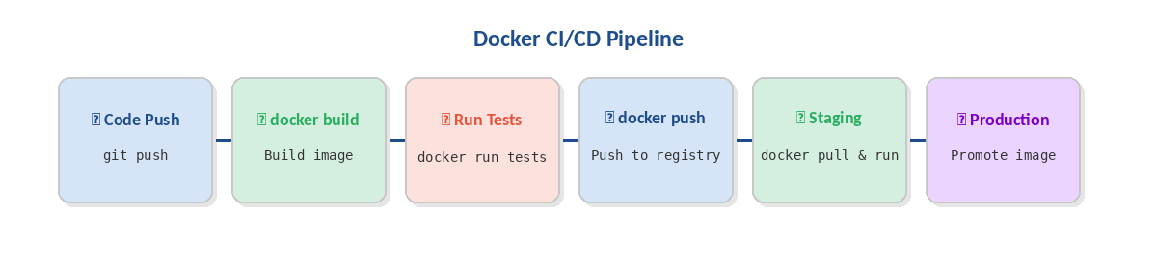
Figure: A Docker image built in CI is promoted unchanged through staging to production

11.1 GitHub Actions — Complete Example
name: Build and Deploy

on:
push:
branches: [main]

jobs:
build:
runs-on: ubuntu-latest
steps:
- uses: actions/checkout@v4

- name: Log in to Docker Hub
uses: docker/login-action@v3
with:
username: ${{ secrets.DOCKERHUB_USERNAME }}
password: ${{ secrets.DOCKERHUB_TOKEN }}

- name: Set up Docker Buildx (enables BuildKit + caching)
uses: docker/setup-buildx-action@v3

- name: Build and push
uses: docker/build-push-action@v5
with:
push: true
tags: |
username/myapp:${{ github.sha }}
username/myapp:latest
cache-from: type=gha
cache-to: type=gha,mode=max

⚠️ WARNING
Never push an image tagged :latest as the only tag in CI/CD. Always also tag with the git SHA or build number so you can trace exactly which code version is deployed in production.

12. Best Practices

12.1 Image Optimization
- Use minimal base images — prefer alpine or -slim variants
- Combine RUN commands with && to reduce layer count
- Copy dependency manifests before source code (cache dependencies)
- Use multi-stage builds — keep build tools out of production images
- Always specify exact image tags — never rely on :latest in production
- Add a comprehensive .dockerignore — exclude node_modules, .git, *.log, .env

12.2 Security
- Run as a non-root user — add USER instruction before CMD
- Never store secrets in Dockerfiles or image layers — inject at runtime
- Scan images regularly: docker scout cves myapp:latest
- Set resource limits: --memory 512m --cpus 1.5
- Use read-only filesystems where possible: docker run --read-only
- Keep base images updated and rebuild frequently

12.3 Production Readiness Checklist
- Health checks defined (HEALTHCHECK or Compose healthcheck)
- Restart policy configured (restart: unless-stopped)
- Resource limits set (memory, CPU)
- Secrets injected at runtime — not baked into image
- Logging to stdout/stderr (not files) — enable log rotation
- Images tagged with semantic versions AND git SHA
- Non-root user specified in Dockerfile
- Vulnerability scanning in CI pipeline (Docker Scout or Trivy)
- Graceful shutdown handler for SIGTERM in application code

13. Real-World Use Cases
Docker appears at every stage of modern software. Here are the six most impactful patterns, with the diagram below showing the most architecturally significant one.

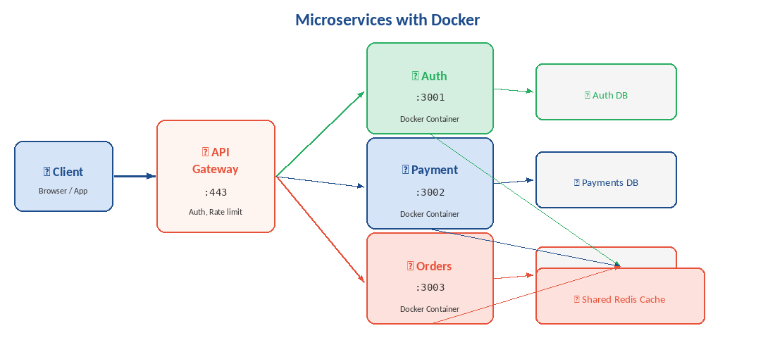
Figure: Each microservice runs in its own container with its own database — independently deployable and scalable

13.1 Microservices Architecture
Break monolithic applications into independent services — each in its own container with its own dependencies. Deploy, scale, and update each service independently without touching the others.
- Update the payment service without redeploying auth or orders
- Scale only the image-processing service to 20 replicas under load
- Use Go for the API gateway, Python for ML inference, Node for the frontend — all in Docker

13.2 CI/CD — Guaranteed Environment Parity
Build the Docker image once in CI. That exact image — not rebuilt — is promoted through staging to production. What was tested is exactly what gets deployed.

13.3 Machine Learning & AI
ML environments are notoriously hard to reproduce. Docker packages the exact CUDA version, Python runtime, and library versions so models train and serve identically on any machine.
- Share a Jupyter notebook environment as a Docker image — docker run = instant environment
- Scale inference APIs horizontally behind a load balancer
- Reproduce published research exactly, years later

13.4 Developer Onboarding
New team members go from zero to a fully working environment in minutes, not days:
git clone https://github.com/myorg/myapp
docker compose up
# Full application running at http://localhost:3000
# Database seeded, Redis running, hot-reload active
# Zero setup documentation required

13.5 Cloud Migration
Containerize existing applications as the first step of cloud migration. Once Dockerized, the app deploys to AWS, GCP, or Azure without code changes — avoiding vendor lock-in at the application layer.

13.6 Testing & QA
Spin up a production-replica environment in CI, run the full test suite, tear it down — all automatically on every pull request.
docker compose -f docker-compose.test.yml up -d
npm run test:integration
docker compose -f docker-compose.test.yml down -v

14. Troubleshooting

14.1 Debugging Commands
Command | Description
docker logs -f container | Stream live logs
docker exec -it container sh | Open interactive shell inside running container
docker inspect container | Full metadata: mounts, networks, env vars, exit code
docker stats | Live CPU, memory, network, and disk I/O per container
docker top container | Show processes running inside the container
docker run -it --entrypoint sh img | Override entrypoint to debug a failing container
docker events | Stream real-time Docker daemon events
docker system df | Show disk usage by images, containers, and volumes

14.2 Common Problems & Fixes
Command | Description
Port already in use | Stop the conflicting host process or use a different host port: -p 8081:80
Container exits immediately | Run docker logs container; or override: docker run -it --entrypoint sh img
Permission denied on volume | Check file ownership; set correct USER in Dockerfile; use --user flag
Out of disk space | docker system prune -a --volumes to recover space
Cannot connect to daemon | Is Docker running? Are you in the docker group? Run: sudo systemctl start docker
Build context too large / slow | Add large directories to .dockerignore
Slow builds | Optimize layer order for caching; use --mount=type=cache in RUN
Image not found | Check registry, image name, and tag; run docker pull image:tag first

14.3 System Cleanup
docker container prune # Remove stopped containers
docker image prune -a # Remove all unused images
docker volume prune # Remove unused volumes
docker network prune # Remove unused networks
docker system prune -a --volumes # Remove everything unused
docker system df # Show current disk usage

15. Quick Reference

15.1 Essential docker run Flags
Command | Description
-d | Detached (background) mode
-it | Interactive terminal (-i = stdin open, -t = pseudo-TTY)
-p host:container | Publish port
-v vol:/path | Mount volume or bind mount
-e KEY=VALUE | Set environment variable
--env-file .env | Load env vars from a file
--name NAME | Assign a name to the container
--rm | Auto-remove container on exit
--network NET | Connect to a specific network
--restart POLICY | Restart policy: no / always / unless-stopped / on-failure
--memory 512m | Set memory limit
--cpus 1.5 | Set CPU limit
--read-only | Mount root filesystem as read-only
--user USER | Run as a specific user/UID

15.2 Production Dockerfile Template
FROM node:20-alpine

# Non-root user for security
RUN addgroup -S app && adduser -S app -G app

WORKDIR /app

# Dependency caching layer
COPY package*.json ./
RUN npm ci --only=production

# Source code (changes most often — last)
COPY --chown=app:app . .

USER app

EXPOSE 3000

HEALTHCHECK --interval=30s --timeout=5s --retries=3 \
CMD wget -qO- http://localhost:3000/health || exit 1

CMD ["node", "server.js"]

15.3 Further Resources
- Official Documentation: https://docs.docker.com
- Docker Hub (registry): https://hub.docker.com
- Play with Docker (lab): https://labs.play-with-docker.com
- Docker Scout (scanning): https://scout.docker.com
- The Twelve-Factor App: https://12factor.net

Docker Comprehensive Guide · Structured for clarity, built for production.

